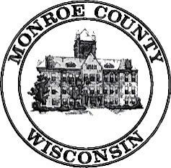 | Local Emergency Planning Committee (LEPC)  Thursday, July 27, 2017  10:00am  Monroe County Courthouse/Assembly Hall  112 S Court St, Sparta WI 54656
Meeting called by: Dave Kuderer, Chair

----- Agenda -----
- Call Meeting to Order
- Introductions
- January 26, 2017 Minutes-Discussion/Action
- Review LEPC Membership List-Discussion
- 2017 EPCRA Organic Valley TTX-Discussion Only
- Strategic Plan-Discussion Only
- National Night out-Discussion Only
- EPCRA Off-Site Plan Update-Discussion
- VPP Group, LLC.
- Sparta Water Department Service Building
- Sparta Well #7, 9, and 10
- Century Foods Plan 1, 2-3, & 4
- Century Link
- Coveris, LLC.
- New Plan Developments
- Rosen’s Inc-Sparta Warehouse
- Warrens Cold Storage/CranGrow
- American Bottling
- Arena Container
- Northern Engraving
- HazMat Team Training Report-Discussion
- HazMat Spill Report and Responses-Discussion
- Old Business
- New Business
- Adjournment

Next meeting: Date and Time to be determined in January 2018; Location: TBD

