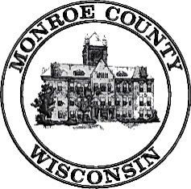 | Local Emergency Planning Committee (LEPC)  Thursday, January 26, 2017  11:00am  Tomah Police Department  805 Superior Ave, Tomah WI 54660
Meeting called by: Matt Modjeski, Vice-Chair

----- Agenda -----
- Call Meeting to Order
- Introductions
- July 21, 2016 Minutes-Discussion/Action
- Review LEPC Membership List-Revise if Necessary
- By-Law Review-Discussion/Action if Necessary
- Election due to vacancy
- Chairman
- 2017 EPCRA Organic Valley TTX-Discussion Only
- Strategic Plan-Discussion Only
- Review WHOPRS/EPCRA info on Reporting Facilities-Discussion Only
- LEPC Compliance Inspector - Review Designation-Discussion
- Procedure for receiving and processing public requests-Discussion/Action if Necessary
- EPCRA Off-Site Plan Update-Discussion
- VPP Group, LLC.
- Sparta Water Department Service Building
- Sparta Well #7, 9, and 10
- New Plan Developments
- Rosen’s Inc-Sparta Warehouse
- Warrens Cold Storage/CranGrow
- HazMat Team Training Report-Discussion
- HazMat Spill Report and Responses-Discussion
- Mass Casualty Trailer Update
- Old Business
- New Business
- Adjournment

Next meeting: Date and Time to be determined in July 2017; Location: TBD

