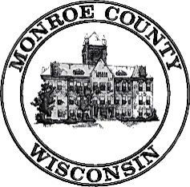 | Local Emergency Planning Committee (LEPC)  Thursday, January 25, 2018  10:00am  Monroe County Assembly Room/County Board Room  112 S Court St, Sparta WI 54656
Meeting called by: Dave Kuderer, Chair

----- Agenda -----
- Call Meeting to Order
- Introductions
- July 27, 2017 Minutes-Discussion/Action
- Review/Revise LEPC Membership List-Discussion/Action
- By-Law Review-Discussion/Action if Necessary
- Election
- Chairman
- Vice-Chairman
- Secretary/Information Officer
- 2017 EPCRA Organic Valley TTX-Discussion Only
- 2018 EPCRA Americold TTX-Discussion Only
- 2018 Monroe/Jackson Joint DOT Exercise-Discussion Only
- Strategic Plan-Discussion Only
- Review WHOPRS/EPCRA info on Reporting Facilities-Discussion Only
- LEPC Compliance Inspector - Review Designation-Discussion/Action if Necessary
- Procedure for receiving and processing public requests-Discussion/Action if Necessary
- EPCRA Off-Site Plan Update-Discussion
- Walmart DC
- Foremost Farms
- Ocean Spray
- CROPP COOP-Organic Valley
- Americold
- Sparta COOP
- New Plan Developments
- Northern Engraving
- All American Bottling
- Arena Container
- HazMat Team Training Report-Discussion
- HazMat Spill Report and Responses-Discussion
- National Night Out-Discussion Only
- Health Department PHEP Review
- Old Business
- New Business
- Adjournment

Next meeting: Date and Time to be determined in July 2018; Location: TBD

