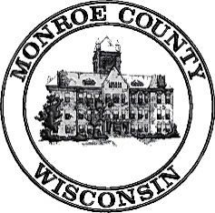 | Local Emergency Planning Committee (LEPC)  Wednesday, January 23, 2019  10:00am  Tomah Police Department  809 Superior Ave, Tomah WI 54660
Meeting called by: Dave Kuderer, Chair

----- Agenda -----
- Call Meeting to Order
- Introductions
- July 26, 2018 Minutes-Discussion/Action
- Review/Revise LEPC Membership List-Discussion/Action
- By-Law Review-Discussion/Action if Necessary
- 2018 EPCRA Americold Functional-Discussion Only
- 2019 Monroe/Jackson Joint DOT Functional Exercise-Discussion Only
- Strategic Plan-Discussion Only
- Review WHOPRS/EPCRA info on Reporting Facilities-Discussion Only
- Warrens Cold Storage Anhydrous Ammonia Leak-Discussion
- LEPC Compliance Inspector - Review Designation-Discussion/Action
- Procedure for receiving and processing public requests-Discussion/Action if Necessary
- EPCRA Off-Site Plan Update-Discussion
- Sparta Water Dept Service Building
- Sparta Well #7, #9, and #10
- Trans Continental Packaging (formerly Coveris)
- CenturyLink - Tomah
- Warrens Cold Storage
- HazMat Team Training Report-Discussion
- HazMat Spill Report and Responses-Discussion
- Old Business
- New Business
- Adjournment

Next meeting: Date and Time to be determined in July 2018; Location: TBD

