It’s beginning to look a Lot Like Christmas...

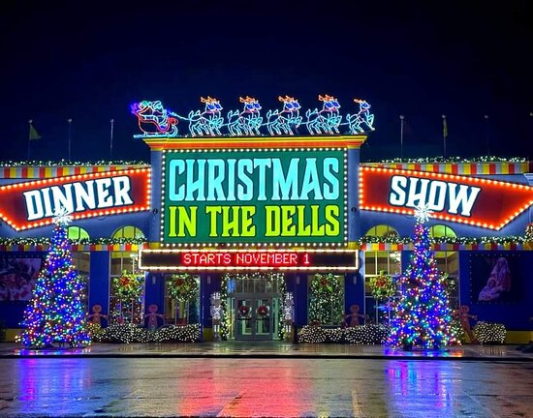 Vintage Vagabonds travel to the Legacy Dinner Theater in Wisconsin Dells on Tuesday, December 3 to see *Christmas in the Dells Dinner Show. Christmas in the Dells Dinner Show* is a BRAND NEW multi-million dollar Christmas production in Wisconsin Dells that features sugar plum fairies, soaring angels, dancing elves, enchanted reindeer, Jolly ol’ Saint Nick, and the celebration of the birth of Christ with the area’s largest living nativity!

Cost for December Trip: $105 includes transportation on Lamers Deluxe Motorcoach, meal including gratuity, and show. Pick up times: Sparta- 11:30 a.m. and Tomah -Noon at Southeast corner of Wal-Mart parking lots. Estimated return times: Tomah: 5:15 pm and Sparta 5: 45 pm. Deadline for registering: November 5.he Vintage Vagabond link on the left side of t

Please complete the form below and either mail or bring in person to the ADRC office. Cash or check must accompany your reservation. Make checks out to ADRC of Monroe County. If you have never traveled with ADRC Vintage Vagabonds,please complete a medical emergency form which can be found at our website. https://www.co.monroe.wi.us/departments/aging-and-disability-resource-center/senior-vintage-vagabond-trips**.**

>>>>>>>>>>>>>>>>>>>>>>>>>>>>>>>>>>>>>>>>>>>>>>>>>>>>>>>>>>>>>>>>>>>>>>

RESERVE YOUR SPOT TODAY- **Deadline: November 5**

Vintage Vagabond Trip:  **December 3 Wisconsin Dells Christmas Show**

Number attending: ___________ Pick up location: Tomah ____ or Sparta ____

Name(s) (Please print) 1._____________________________________2.______________________________

X if age 60+ ____ X if age 60+____

Address w/ city:__________________________________________________________

Phone number:_________________________Email____________________________

Meal: 4 Course Dinner featuring Ham/Turkey and all the holiday fixins served family style at each table.

Payment: Total Enclosed $__________ Cash_____ or Check _____

**Mail or bring in person to: ADRC, 315 W. Oak St, Suite A Sparta, WI 54656**

**>>>>>>>>>>>>>>>>>>>>>>>>>>>>>>>>>>>>>>>>>>>>>>>>>>>>>>>>>>>>>**