**Vintage Vagabond June Trip- From Gardens to Government!**

Vintage Vagabonds in June is venturing to our state capitol, Madison. Our day begins at Olbrich Botanical Gardens. Stroll through 16 acres of outdoor display gardens and an indoor, tropical conservatory. In the outdoor gardens, visit the Royal Thai Pavilion and Garden. Olbrich's Thai Pavilion is the only one in the continental United States and the only one outside of Thailand surrounded by a garden. Explore other specialty gardens such as the Perennial Garden, Sunken Garden, and Herb Garden.

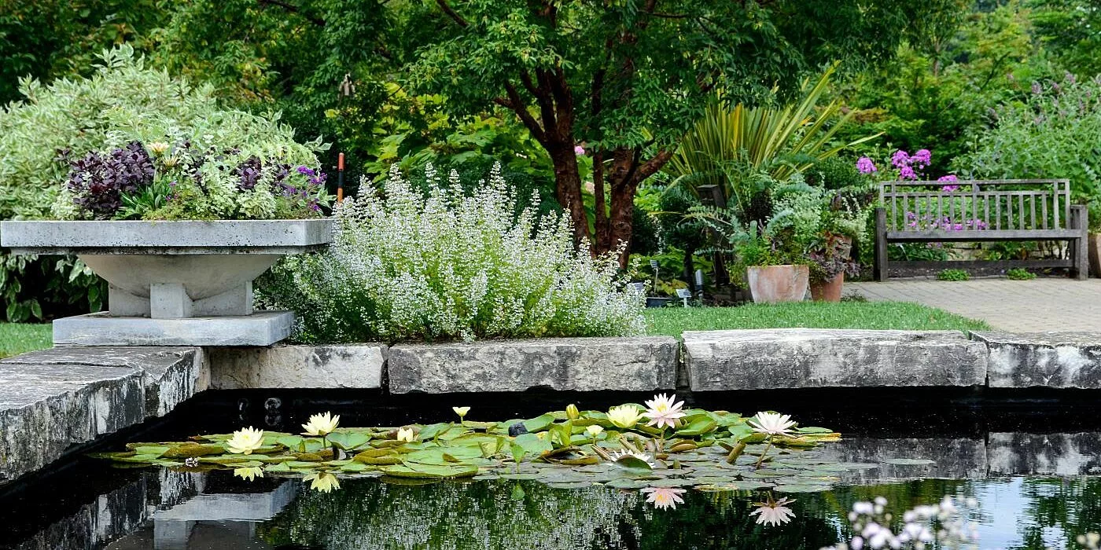

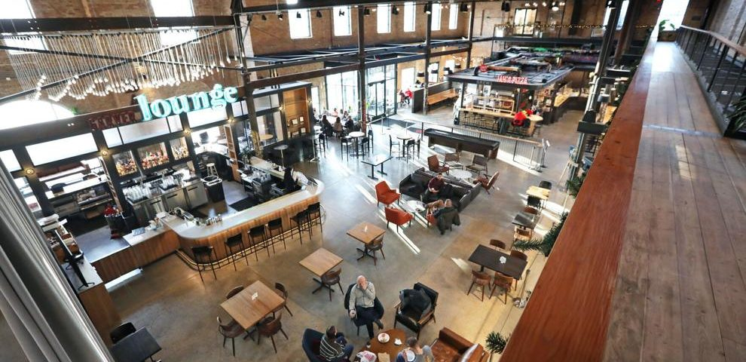

Our lunch stop will be next door to the gardens at the Garver Feed Mill, an award winning turn-of-the-century building.This renovated Feed Mill honors and preserves Madison's rich agricultural and industrial history providing visitors with the opportunity to taste the best of Madison. You will get the opportunity to taste some of Madison’s most unique pizza and homemade ice cream.

The best way to experience the beauty and grandeur of Wisconsin's Capitol building is to see it for yourself. After lunch we will do just that with a guided tour.

Cost is $54 per person which includes transportation on a Lamers Deluxe Motorcoach, lunch (including gratuity) and all admission/tour fees. Pick up times: Sparta Wal-Mart 7:45 a.m. and Tomah Wal-Mart 8:15 a.m. Pick up is in southeast corner of parking lots.

Estimated return times: Tomah- 3:45 p.m. and Sparta - 4:15 p.m.

Please complete the form below and either mail or bring in person to the ADRC office. Cash or check must accompany your reservation. Make checks out to ADRC of Monroe County. If it has been more than a year since you traveled with us, we will also need you to complete a Medical Emergency Form which can be found at our website. https://www.co.monroe.wi.us/departments/aging-and-disability-resource-center/senior-vintage-vagabond-trips

>>>>>>>>>>>>>>>>>>>>>>>>>>>>>>>>>>>>>>>>>>>>>>>>>>>>>>>>>>>>>>RESERVE YOUR SPOT TODAY**- Registration opens: April 12 Deadline: May 20**

Vintage Vagabond Trip: **June 26 Madison-Olbrich Gardens and Capitol Tour**

Number attending: ___________ Pick up location: Tomah ____ or Sparta ____

Name(s) (Please print) 1._____________________________________2.______________________________

X if age 60+ ____ X if age 60+____

Address w/ city: _______________________________________________________

Phone number: ________________________Email: ____________________________

Meal Choice: (Pizza Buffet this trip)

Payment: Total Enclosed $__________ Cash_____ or Check_____

Mail or bring in person to: ADRC, 315 W. Oak St, Suite A Sparta, WI 54656

>>>>>>>>>>>>>>>>>>>>>>>>>>>>>>>>>>>>>>>>>>>>>>>>>>>>>>>>>>>>>>>