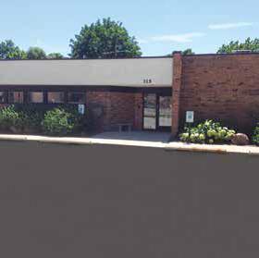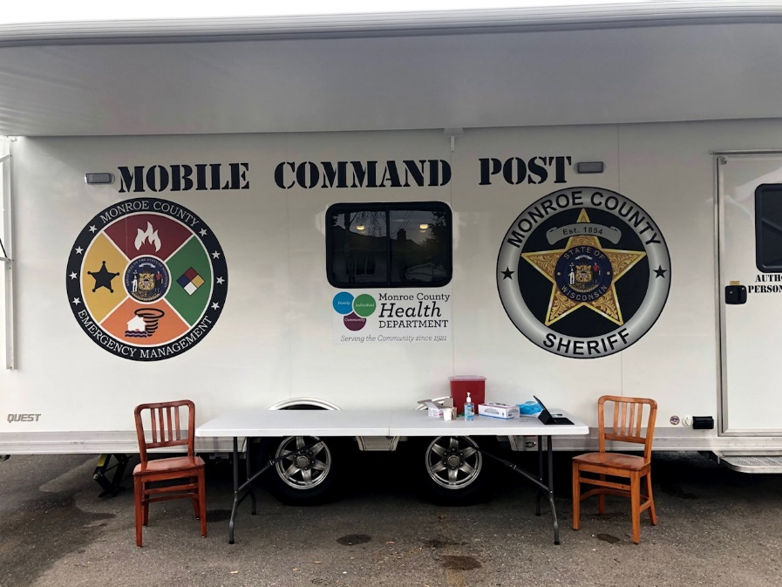

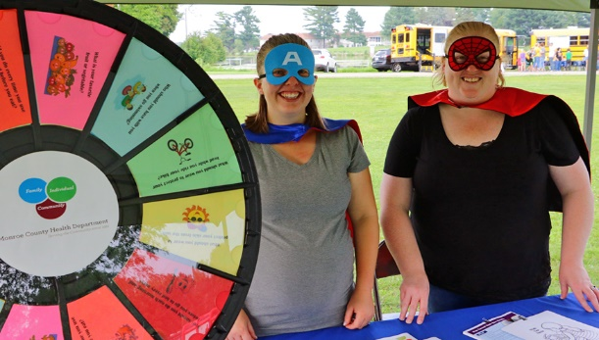Ma

Annual Report 2021

To County Administrator Osterberg, Health and Human Services Board Members, County Board Supervisors, Colleagues, Partners, and Citizens:

I am pleased to share the 2021 Monroe County Health Department Annual Report. To say that 2021 was challenging would be an understatement. We began the year with a transition to new leadership, continued with new staff, experienced a change in climate around the pandemic response, and responded to the arrival of 13,000 Afghan guests.

While there were many challenges, it was a time to remember the importance of Public Health and for the Health Department to celebrate providing 100 years of service to the community. Ann Finchenberger was hired on July 1, 1921, as the first Monroe “county nurse.” Her assignment included checking the sick and quarantining people in their homes if a communicable disease was detected or suspected, identifying children with debilitating conditions, and arranging for state-supported treatment. Since that time, public health’s role has evolved.

I would like to extend my appreciation to the health department staff, County Administrator, Health and Human Services Board, and our community partners for the support in providing services to county residents that support improving the health of all residents.

Health departments are required to make certain that three core public health functions and 10 essential public health services are available to County Residents. These functions and services represent activities and responsibilities that are shared between the health department, government, and public, private, and voluntary agencies and organizations across all sectors and communities to achieve public health goals. These core functions serve to align policies and systems to assure that where we live, work and play are part of a healthy, safe, and resilient community. The following will provide an introduction to the core public health functions and corresponding essential services and highlight the related services provided by Monroe County Health Department.

If you have any questions regarding public health in Monroe County, please feel free to call or visit us at 315 W. Oak Street, Sparta.

I look forward to continuing to protect, promote and improve the health of county residents.

Sincerely,

Tiffany Giesler RN, BSN

Director/Health Officer

**Core Function1: Assessment**  
*Assessment entails all activities involved in community diagnosis such as disease  
surveillance, identifying current and emerging needs, analyzing the underlying  
causes of problems, collecting and interpreting data, case finding, monitoring and  
forecasting trends, research, and evaluation of outcome*

**Essential public health services that relate to this core function**  
1. **Monitor the health status of populations to identify and solve community health problems.** *This means monitoring and assessing the community’s health status, identifying the community’s strengths (assets) and challenges (threats), and determining the current and emerging health needs.*

**Compass Now Report**

In 2021, the Health Department, in collaboration with Great Rivers United Way, area healthcare organizations, and other local health departments, completed a Community Health Needs Assessment (CHA) Compass Now report. The report compiled includes an analysis of community indicators and insights provided by public health, healthcare, and community sector stakeholders as well as community insights gathered through random household and convenience surveys.

**County Health Rankings**

The County Health Rankings Model is based on factors that influence how long and how well we live. This model takes into account 30 measures that help communities understand the health of residents today (health outcomes) and the impact on health in the future (health factors). Wisconsin Counties are ranked among all 72 counties in the state. According to the 2021 County Health Rankings, Monroe County is ranked as follows:

|  |  |  |  |
| --- | --- | --- | --- |
| Overall Rank- 50 | Length of Life- 54 | Quality of Life- 43 | Socio and economic factors -34 |
| Health Factors- 31 | Health Behaviors- 53 | Clinical Care- 25 | Physical Environment- 20 |

Based on the information gathered through community stakeholder meetings, community surveys, community demographics, and County Health Rankings data, the following priority needs were identified:

1. Poverty and Livable wages
2. Mental Health-Access to treatment, stigma, suicide
3. Safe, Affordable Housing
4. Culture of Drug and Alcohol Use and related crime
5. Obstacles to receiving healthcare- appointment time, childcare, transportation
6. Physical Inactivity and Obesity
7. Insurance Access and Education on Resources to help pay for care

As we move into 2022, MCHD will continue to meet with our community stakeholders and residents to prioritize needs and develop a Community Health Improvement Plan.

[2021 Compass Now Report](https://www.greatriversunitedway.org/wp-content/uploads/2021/08/2021-compass-now-report_monroe.pdf)

[2021 Monroe County Health Rankings](https://www.countyhealthrankings.org/app/wisconsin/2021/rankings/monroe/county/outcomes/overall/snapshot)

**2. Investigate and diagnose community health problems and health hazards.**

*This means using health laboratories and other resources to investigate disease outbreaks and patterns of environmental health hazards, chronic disease, and injury. It also includes identifying relationships between environmental conditions and the public’s health and developing and implementing prevention and intervention strategies.*

**Communicable Disease Control:**

Surveillance, Investigation, and follow-up of reportable communicable diseases are statutorily required of local health departments.

|  |  |
| --- | --- |
| Multisystemic inflammatory syndrome in children | 1 |
| Mycobacterium non tuberculosis | 3 |
| Salmonella | 11 |
| Shigellosis | 2 |
| Strep pneumonia | 2 |
| Streptococcal disease | 5 |
| Streptococcus pneumoniae invasive | 3 |
| Syphilis | 4 |
| Tetanus | 1 |
| Toxoplasmosis | 1 |
| Varicella | 1 |
| Vibriosis | 1 |
| Yersiniosis | 1 |
|  |  |
|  |  |
|  |  |

|  |  |
| --- | --- |
| **Communicable Disease** | **5750** |
| Anaplasmosis | 17 |
| Arboviral powassen | 1 |
| Babesiosis | 1 |
| Campylobacter | 24 |
| Carbapenemase | 1 |
| Carbon monoxide poisoning. | 4 |
| Chlamydia | 151 |
| Cryptosporidium. | 19 |
| Cyclosporosis. | 2 |
| COVID-19 POSITIVE | 5269 |
| Ehrlichiosis. | 1 |
| E-Coli-(EPEC) | 36 |
| E-Coli (ETEC) | 6 |
| E-Coli-(STEC) | 3 |
| Giardiasis | 4 |
| Gonorrhea | 24 |
| Haemophilus influenza | 1 |
| Hepatitis A | 1 |
| Hepatitis B | 4 |
| Hepatitis C | 19 |
| Influenza A | 8 |
| Influenza hospitalizations | 7 |
| LTB1 | 8 |
| Lyme | 108 |
| Metal poisoning non-lead | 3 |
|  |  |

**Animal Bites:**

Investigation of reported animal bites for possible rabies exposure is conducted to assure that serious illness or death from the transmission of rabies is prevented. This program is designed to coordinate an effective rabies control procedure between MCHD, law enforcement, veterinarians, and healthcare partners.

Animal bites are reported to MCHD for follow-up. Monitoring of the animal for signs of rabies is done by a licensed veterinarian. If the animal is not able to be monitored or sent in for testing, the bite victim is recommended to have a series of vaccinations that prevents the onset of the fatal rabies virus.

In 2021, the health department followed –up on 16 animal bite exposures. Zero animals were positively identified to have rabies. One victim was started on rabies vaccination following exposure to a bat.

**Immunization Program:**

Immunizations prevent disease in those individuals that receive them, but also protect individuals in the community who are not fully vaccinated or have weakened immune systems. Immunizations not only help to prevent disease and transmission but also decrease the risk of adverse outcomes and death. Children under the age of 2 are most vulnerable to childhood illnesses, which is why they must be protected. In 2021, 58% of 2-year-olds met all benchmark criteria for their age group.

|  |
| --- |
| Selected benchmarks: DTaP (4), HepB (3), Hib (3), MMR (1), Pneumo (4), Polio (3), Varicella (1) |
| Met Benchmark: DTaP (60%), HepB (70%), Hib (70%), MMR (68%), Pneumo (65%), Polio (70%), Varicella (67%) |

The Health Department can provide routine childhood vaccines to individuals who do not have insurance or are underinsured through the State Vaccines for Children and Adults Program.

2021: Outcomes

|  |  |
| --- | --- |
| Immunization (People Seen)....... | 11025 |
| Immunization (Vaccines Given) | 12269 |
| Adult COVID | 9530 |
| Childhood COVID | 1286 |
| Other Vaccines | 64 |

**Seasonal Influenza**

The Health Department provided a quadrivalent seasonal influenza vaccine to those individuals aged 6 months and older. MCHD also offered a high-dose vaccine that is formulated to enhance the immune response of individuals 65+.

2021 Outcomes:

* 50 offsite clinics
* 20 office clinic days
* Influenza vaccines given-1389
* Adult-1205
* Children-185

**Lead Program:**

Before 1978, lead was used in many products such as paint, gasoline, and plastics to preserve effects and conditions. The unfortunate finding since then has been, that lead is toxic to humans and animals. Therefore restrictions have since been established on the use of lead. Since lead was added to paint, gasoline, and varnishes to make them last longer, children are being exposed to unsafe levels of lead in homes, childcare facilities, cosmetics, herbal remedies, and soils. Homes built before 1978 that have not been previously renovated most likely have lead-based paint hazards present.

Exposures of lead in children typically occur within their own home or childcare facility and come from chipping, peeling, or cracking paint. Fine dust is created from these deteriorated surfaces and ends up on floors and walls and in open soil areas where children often play. Children often put their hands in their mouths causing the lead to enter the bloodstream. Another common exposure can be during a renovation project. If proper techniques and abatement are not used, the fine dust particles are spread throughout the home. Harmful exposures in children can cause damage to the brain, and nervous system, slowed growth and development, learning and behavioral concerns, and hearing and speech delays.

The CDC and WI DHS recommend lead testing on children in Wisconsin starting at the age of one year. The state of Wisconsin defines an elevated blood lead level is greater than or equal to 5 mcg/dL. CDC has determined a level greater than or equal to 10 mcg/dL as causing damage to the development and body systems in a child. The Monroe County Health Department has one licensed lead investigator that follows up with phone call education and resources to any blood lead level reported of greater than or equal to 5 mcg/dL and completes a home investigation, lead hazard investigation and nurse visit, education and recommends resources as needed for any blood level reported of greater than or equal to 10 mcg/dL.

The data in this chart is pulled from the Healthy Homes & Lead Poisoning Surveillance System used by the Monroe County Public Health Lead Nurse to gather data, chart phone calls & visits, and monitor lead levels among those in Monroe County.

|  |  |  |  |  |  |
| --- | --- | --- | --- | --- | --- |
| YEAR | 2017 | 2018 | 2019 | 2020 | 2021 |
| TOTAL TEST | 279 | 200 | 177 | 141 | 43 |
| 5-9 mcg/dL | 20 | 21 | 26 | 16 | 11 |
| 10-19 mcg/dL | 14 | 3 | 7 | 7 | 2 |
| ≥ 20 mcg/dL | 4 | 1 | 7 | 0 | 0 |

**Human Health Hazards**

The Health Department investigates complaints subject to provisions of the County Human Health Hazard Ordinance. The goal of this program is to protect the health of the public from illnesses and diseases from health hazards.

2021 Outcomes:

* 27 Human Health Hazard investigations investigated.
* 3 properties condemned for unsafe living conditions.

The Monroe County Health Department contracts with Driftless Region Vector Control, LLC for the prevention and control of vector-borne diseases, specifically, La Crosse Viral Encephalitis.

**Radon**

Radon is a naturally-occurring, radioactive gas that can cause lung cancer. Radon comes from the natural (radioactive) breakdown of uranium in soil and rock and can contaminate water and air in any type of building. Most radon exposure occurs inside homes, schools, and workplaces. Because we cannot see, smell, or taste radon, the only way to know Monroe County homes and businesses are safe, is through testing. Monroe County Health Department offers short-term test kits to all residents for a low cost.

In 2021, the Monroe County Health Department distributed thirty-six short-term radon test kits. Thirty-one of the test results were reported and, seven of the reported results were at or above the Environmental Protection Agency (EPA) recommended action level of 4.01 pCi/L. Residents with high results were given guidance to perform follow-up testing and resources for radon mitigation. Below is a map indicating the location of buildings with radon results that exceeded EPA standards:

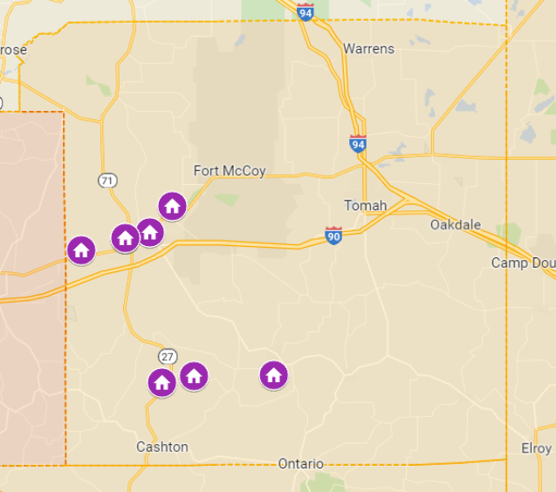

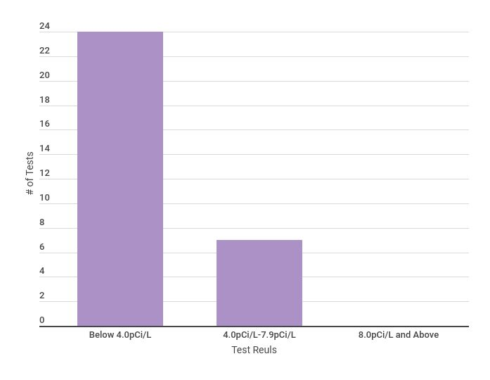

* 36 test kits given out in 2021
* 1 kit was not exposed long enough
* 3 kits were not submitted for testing
* 24 kits were at or below 4
* 7 were between 4-8
* 0 were above 8

**Private Well-Water Testing**

* 47 Test Kits given out
* 3 fee exempt kits to WIC clients
* Forty-seven water testing kits for bacteria, thirteen water testing kits for metals, and one water testing kit for arsenic were distributed to Monroe County residents to be sent to the La Crosse County Health Department for analysis. Additionally, three fee-exempt water testing kits were distributed to WIC clients to be analyzed at the Wisconsin State Lab of Hygiene.

**Core Function 2: Policy Development**  
*Policy development means the process by which communities make decisions about problems, choose goals and proper means to reach them, handle conflicting views about what should be done, and allocate resources.*

**Essential public health services that relate to this core function  
3. Inform and educate individuals about health issues**. *This means promoting  
and engaging in healthy behavior and lifestyles by making health information  
available in a variety of formats, styles, languages, and reading levels so it can  
be effectively communicated to the diverse people of Wisconsin. It also means  
regularly sharing and discussing current and emerging health information,  
statistics, and issues with communities, policy-makers, and decision-makers.*

**General Health Education**

Monroe County Health Department staff provides outreach and education to community groups, school districts, key stakeholders, legislators, and the general public. 2021 topics included: radon, mold and vermin education, information and assistance with finding and accessing community resources, immunizations, post-partum care, nutrition and physical activity, infectious disease and STI prevention, bloodborne pathogens, first aid, mental health, car seat, safe sleep, arsenic, and well water, and other general public health topics.

MCHD strives to use technology to enhance health education and public awareness. The Monroe County Health Department website and Facebook page provide education, information, and awareness about a variety of health topics throughout the year. The Health Department also provides local papers and radio stations with press releases; 83 press releases were sent to be published.

<http://www.co.monroe.wi.us/departments/health-department>

[www.healthymonroecowi.gov](http://www.healthymonroecowi.gov)

**4. Mobilize public and private sector collaboration and action to identify and  
solve health problems.** *This means collaborating with community groups and individuals to identify and address local and statewide health and environmental issues using the underlying determinants of health. It also includes providing needed infrastructure support to build, support, and maintain inclusive partnerships to improve and protect the public’s health. Finally, it includes developing strategies for inviting and engaging the full range of human  
capital, social networks, and community assets to improve health for all.*

Monroe County Health Department partners with the following coalitions and groups to make improvements in our county and region.

* [Child Death Review](https://www.co.monroe.wi.us/?splash=https%3a%2f%2fwww.chawisconsin.org%2finitiatives%2finjury-prevention-death-review%2fchild-death-review%2f&____isexternal=true)
* [Dementia Friendly Monroe County](https://www.dementiafriendlymonroe.org/)
* [Monroe County Safe Community Coalition](https://www.co.monroe.wi.us/?splash=http%3a%2f%2fwww.mcsafecommunities.org%2f&____isexternal=true)-
* [Mental Health Coalition](https://www.co.monroe.wi.us/?splash=https%3a%2f%2fwww.facebook.com%2fmonroecomentalhealthcoalition&____isexternal=true)
* [Nutrition Coalition](https://www.co.monroe.wi.us/?splash=https%3a%2f%2fhealthymonroecowi.org%2fpartnerships%2f&____isexternal=true)
* Resources Empowering Youth
* [Resiliency and Trauma-Informed Communities](https://www.co.monroe.wi.us/?splash=https%3a%2f%2fhealthymonroecowi.org%2fpartnerships%2f&____isexternal=true)
* [Safe Kids Coulee Region](https://www.co.monroe.wi.us/?splash=https%3a%2f%2fwww.safekids.org%2fcoalition%2fsafe-kids-coulee-region&____isexternal=true)
* [Seven C's Health Initiative](https://www.co.monroe.wi.us/?splash=http%3a%2f%2fwww.7cshealthinitiative.com%2f&____isexternal=true)
* [Western Wisconsin Public Health Readiness Consortium](https://www.co.monroe.wi.us/?splash=http%3a%2f%2fwwphrc.org%2f&____isexternal=true)
* [Wisconsin Association of Local Health Departments and Boards](https://www.co.monroe.wi.us/?splash=https%3a%2f%2fwww.walhdab.org%2f&____isexternal=true)
* [Wisconsin Public Health Association](https://www.co.monroe.wi.us/?splash=https%3a%2f%2fwww.wpha.org%2f&____isexternal=true)

5**. Develop policies, plans, and programs that support individual and community health efforts.** *This means providing leadership to drive the development of community health improvement processes, plans, and policies that are consistent throughout the state but address local needs and conditions.*

**MCHD Strategic Plan 2019-2023**

**S**trategic Priority 1: Resource Management

* Goal 1: Build department infrastructure to pursue funding opportunities that align with priorities.
* Goal 2: Create a work environment where employees feel supported and valued.

Strategic Priority 2: Maintain and Build Partnerships/Relationships

* Goal 1: Build and maintain relationships that align with health department priorities

Strategic Priority 3: Public Health Advocacy and Awareness

* Goal 1: Increase understanding of health equity to better inform public health practice.
* Goal 2: Communicate with external stakeholders to increase understanding of the role and value of public health.
* Goal 3: Become a trauma-informed the health department

Strategic Priority 4: Enhance Interdepartmental Teamwork

* Goal 1: Build interpersonal communication and personality awareness skills among staff to improve interdepartmental teamwork
* Goal 2: Develop a clear understanding of employee skill sets and job responsibilities to align staff with identified tasks and maximize efficiency.
* Goal 3: Ensure sufficient and consistent communication of program responsibilities, updates, and acute issues.

**Community Health Improvement Plan 2019-2022**

The Monroe County Community Health Improvement Plan (CHIP) has been developed through the collaborative work of community partners to enhance the health of the community.

[**Monroe County Community Health Improvement Plan 2019-2022**](https://healthymonroecowi.org/wp-content/uploads/2019/08/Monroe-Co-CHIP-19-22.pdf)

**Core Function: Assurance***Assurance means to make certain that necessary services for a community are  
provided to reach agreed-upon goals, either by encouraging public, private, non-  
profit, civic, and voluntary sector action, by requiring it, or by providing services  
directly.*

**Essential public health services that relate to this core function**  
**6. Enforce statutes and rules that protect health and ensure safety.** *This means  
the efficient and effective enforcement of state and local laws and regulations that protect and promote the public’s health.*

**Transient Non-Community Water Testing**

Through a contract with the Wisconsin Department of Natural Resources, 55 facilities in the county that qualify as a Transient Non-community Water System were tested for bacteria and nitrates, and 13 of those wells were inspected to ensure safe and dependable water for the public. 10 seasonal facilities in the county were also tested. One facility was found to have bacteriologically unsafe water and one facility currently posts a public notice as they are operating with nitrate levels between 10mg/L and 20mg/L. A thorough, onsite inspection of the facility’s water system is conducted annually to determine a cause, if any, of potential sanitary defects.

* 41 Annual Site Visits Completed
* 13 Sanitary Surveys Completed
* 55 Total Inspections Completed
* 10 Seasonal Sites

MCHD follows local ordinances and State Statute to enforce laws and regulations related to human health hazards and communicable diseases.

**7. Link individuals to needed personal health services.** *This means providing education, outreach, case-finding, referral, care coordination, navigation, and other services that help individuals and families access high-quality health and public health services.*

**Women, Infant, and Children (WIC) Nutrition Program**

The purpose of the Special Supplemental Nutrition Program for Women, Infants, and Children (WIC) is to promote and maintain the health and well-being of nutritionally at-risk pregnant, breastfeeding, and postpartum women, infants, and children up to age 5. WIC provides supplemental nutritious foods, nutrition and breastfeeding information, and referrals to other health and nutrition services. Income eligibility requirements for WIC extend to 185% of the poverty level. The WIC foods align with the Dietary Guidelines for Americans and infant feeding practice guidelines of the American Academy of Pediatrics. It promotes WIC as the premier public health nutrition program with a strong focus on breastfeeding as the normal way to feed babies. Foods provided include fruits and vegetables; whole grains such as 100% whole wheat bread, buns, rolls, tortillas, or brown rice, hot or cold cereal; protein foods such as peanut butter, beans, peas, eggs, and canned fish; milk, yogurt, cheese, and tofu; baby foods and formula. The WIC Farmer’s Market Nutrition Program provides vouchers for families to purchase fresh produce from local farmers.

Monroe County WIC Project:

|  |  |
| --- | --- |
| Clinic Days | 236 |
| Total Clients in Program | 889 |
| Women | 250 |
| Infants. | 164 |
| Children | 475 |

**WIC Breastfeeding Peer Counseling Program**  
The WIC Breastfeeding Peer Counseling Program provides frequent contacts to pregnant and breastfeeding mothers for breastfeeding promotion and support. A Peer fills a unique niche in providing support to WIC participants when they need it most, which often includes evenings and weekends. Peers have basic breastfeeding knowledge to assist mothers with common concerns. She also can relate well to the WIC mothers through her own experience with WIC and breastfeeding. The WIC Breastfeeding Coordinator has specialized training to  
assist mothers with more complex problems.

**Fit Families Program**  
Fit Families is a public health nutrition program funded under the USDA’s Supplemental Nutrition Assistance Program for families with children ages 2 to 4 years old. It strives to prevent childhood overweight/obesity by providing individual coaching to empower families to adopt healthy eating and physical activity behaviors. In addition to engaging families, the program also encourages a healthy lifestyle for agency staff and partners with community groups to reinforce Fit Families health messages and to promote and protect the health of all children in the community.

**Community Support Program (CSP**)  
The Community Support Program provides client-focused individualized community-based services to people diagnosed with severe and persistent mental illness. Treatment is provided by a multi-disciplinary team in collaboration with the individual, their family, and the community where the individual resides. The goal of the program is to reduce the disabling effects of the individuals’ psychiatric symptoms through evidence-based practices, education, and supportive resources. Services emphasize community-based treatment to reduce the need for hospitalization and institutional care and allow individuals to achieve the highest level of functioning and quality of life they are capable of living.

Monroe County Public Health Nurse provided 163 CSP visits.

**Cribs for Kids**

Cribs for Kids is a safe sleep program for low-income parents, families, and caregivers to help reduce the risk of injury and death of infants due to unsafe sleep environments. Cribs for Kids provides families with a portable Pack ‘n Play crib and educational materials regarding safe sleep (which includes tips on how to protect their baby). A Cribs for Kids intake questionnaire is completed by an MCHD public health nurse for every caregiver receiving a crib. Caregivers are screened for eligibility and need. A nurse presents and reviews educational materials related to safe-sleep practices and demonstrates how to correctly assemble the crib. This program is funded through the Kindness Community donation. Cribs were provided to 3 families in 2021.

**Car Seat Program**

MCHD secured a State Department of Transportation (DOT) grant to supply care seats to eligible, low-income Monroe County residents. A total of 20 car seats were issued and 21 participants received education on proper use and installation. The Health Department has 2 Certified Child Passenger Safety Technicians.

**8. Assure a competent public health workforce**. *This means leading and supporting efforts to improve the quality, quantity, and diversity of the public health workforce. This includes promoting the development of professional education strategies and programs that address state and local health needs.*

* Training provided on Health Equity
* Began Succession Planning and process mapping for core programs
* Development of Onboarding and Orientation Manual
* Staff attended training covering various common training topics such as incident command, MCH regional workgroup, communicable disease surveillance and control, Tuberculosis Summit, Trauma-Informed Care and CPR
* The department also supported staff attendance at professional organization annual  
  conferences such as WAHLDAB, WPHA, and WIC

**Linkages with Academia**  
The Health Department continues to have a strong relationship with institutions of higher learning and strives to provide students with internships or other opportunities that will enhance their learning about the discipline of Public Health, Community Health Education, and Dietetics.

**9. Evaluate effectiveness, accessibility, and quality of personal and population-  
based health services.** *This means regularly evaluating the public health system’s performance to include programs, processes, results, and outcomes. It includes providing information necessary to define accountability, allocate resources, reshape policies, and redesign services. It includes aligning policies and systems to improve productivity, prosperity, participation, and well-being of the people of Wisconsin.*

**Consolidated Contract and State Grant Program Reviews**  
Each year the State Division of Public Health (DPH) enters into contracts with local health departments for the provision of grant dollars targeting various public health initiatives. These grants are performance-based and require the attainment of negotiated objectives to assure funding.

Program objectives were met in the following programs: Prevention, Lead, Maternal Child Health, WIC, and Public Health Preparedness.

**10. Provide research to develop insights into innovative solutions for health problems.** *This means developing partnerships with institutions, colleges, vocational and technical colleges, and universities to broaden the range of public health research to eliminate health disparities, and testing innovative approaches to what works to improve and protect the health of the public. This  
includes conducting timely scientific analysis of current and emerging public health issues.*

* Continue Linkages with institutes of higher learning and research
* Establish internal capacity for outbreak investigations
* Conduct Community Needs assessments