Getting You in the Christmas Spirit for November Vintage Vagabond Outing

Our final trip for the season on Friday, November 17 takes us to the Clauson Family Music Show near Coloma, WI. Their annual Christmas show located in a historic, restored barn theatre is the perfect way to start off the holiday season! Also enjoy browsing the shops and bakery on the property.

Cost is $85 per person which includes transportation on a Lamers Deluxe Motorcoach, a buffet lunch, the show, and gratuity. Pick up times: Sparta Wal-mart 10:00 a.m. and Tomah Wal-mart 10:30 a.m. 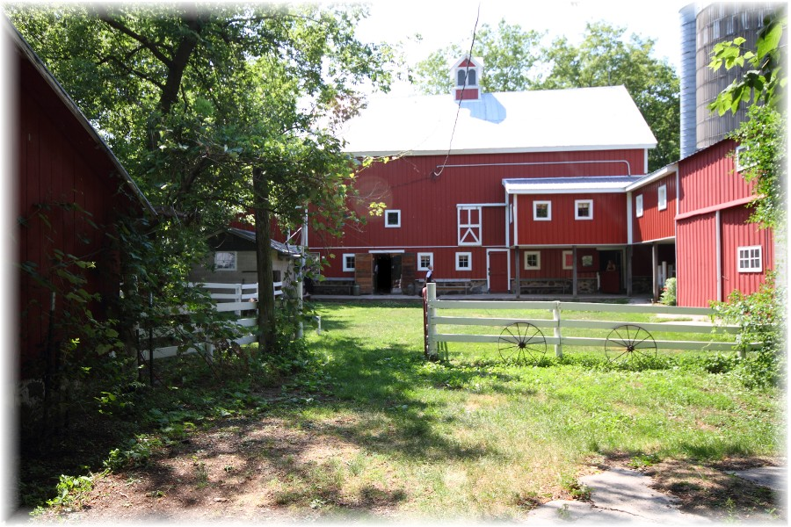in the Southeast corner of the Wal-mart parking lots.

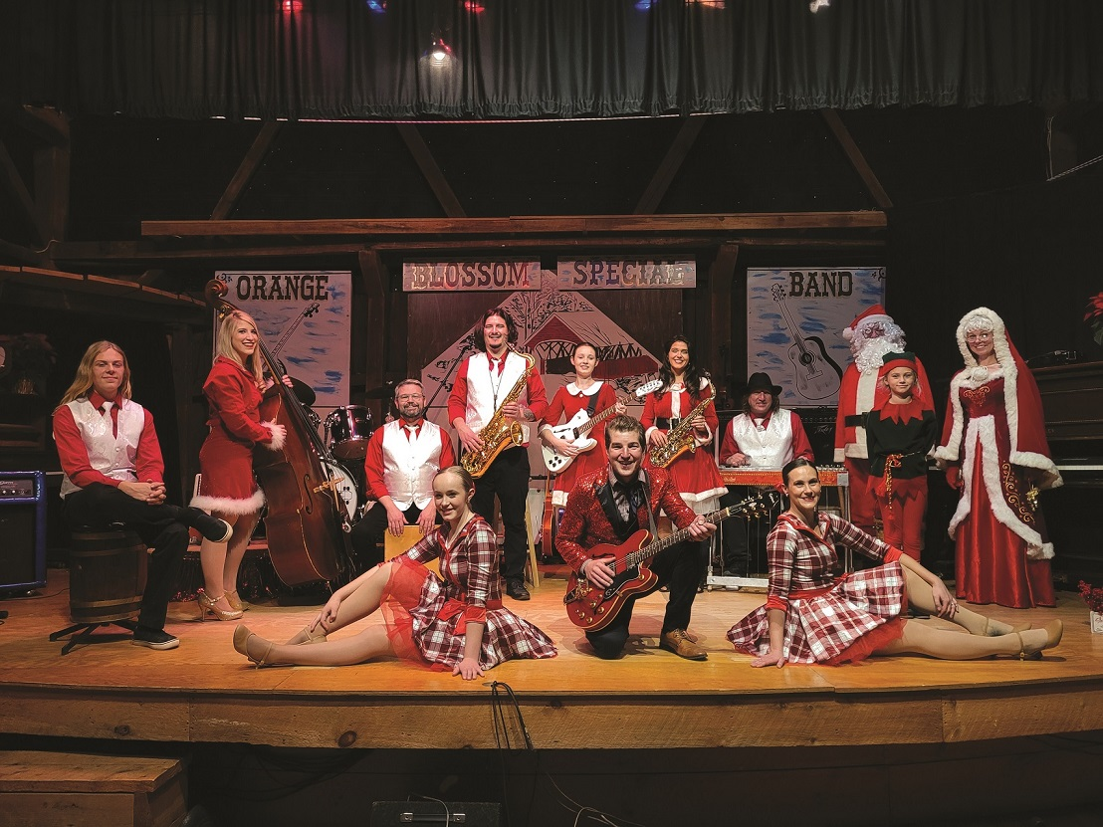

We have a new process for registering for trips this year. Please complete the form below and either mail or bring in person to the ADRC office. Cash or check must accompany your reservation. Checks should be made out to Monroe County ADRC. We will also need you to complete a Medical Emergency Form which can be found at our website. [https://www.co.monroe.wi.us/departments/aging-and-disability-resource-center/senior-vintage-vagabond-trips](https://www.co.monroe.wi.us/departments/aging-and-disability-resource-center/senior-vintage-vagabond-trips%20%20%20)

Please share trip information with friends and family that might want to join us.

>>>>>>>>>>>>>>>>>>>>>>>>>>>>>>>>>>>>>>>>>>>>>>>>>>>>>>>>>>>>>>RESERVE YOUR SPOT TODAY- **Deadline: October 12**

Vintage Vagabond Trip: **November 17 Clauson Family Christmas Show**

Number attending: ___________ Pick up Location: Sparta_____ Tomah____

Name(s) (Please print) 1._____________________________________2.______________________________

X if age 60+ ____ X if age 60+____

Address (including City):__________________________________________________

Phone number: _________________________Email____________________________

Meal Choice: (Buffet for this trip)

Payment: Total Enclosed $__________ Cash_____ or Check_____

Mail or bring in person to: ADRC, 315 W. Oak St, Suite A Sparta, WI 54656

>>>>>>>>>>>>>>>>>>>>>>>>>>>>>>>>>>>>>>>>>>>>>>>>>>>>>>>>>>>>>>>