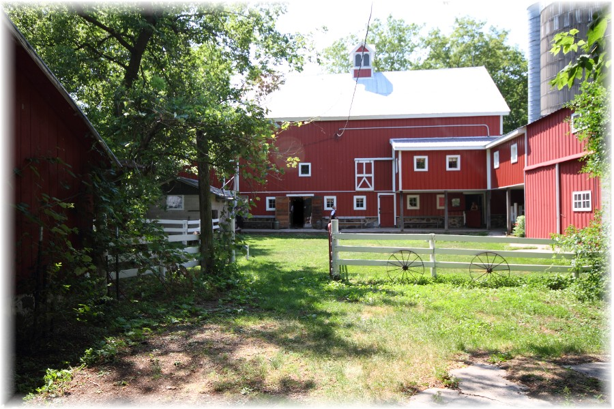Vintage Vagabond Trips are Back for 2023

After a long winter, we are ready to get back on the road!! Our first trip on Thursday, April 27 takes us to the Clauson Family Music Show near Coloma, WI. Show will feature songs of Country Music Legends in a historic, restored barn theatre. Also enjoy browsing the shops and bakery on the property.

Cost is $85 per person which includes transportation on a Lamers Deluxe Motorcoach, a buffet lunch, show, and gratuity. Pick up times: Sparta Wal-Mart 9:45 a.m. and Tomah Wal-Mart 10:15 a.m.

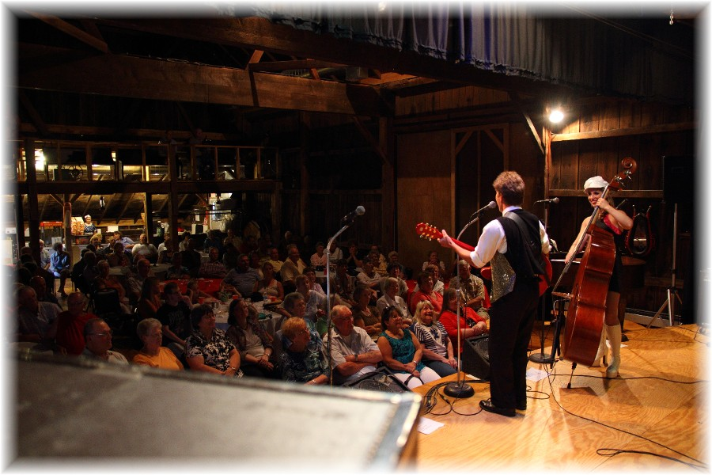

We have a new process for registering for trips this year. Please complete the form below and either mail or bring in person to the ADRC office. Cash or check must accompany your reservation. Keep checking the ADRC website for information on upcoming 2023 trips https://www.co.monroe.wi.us/departments/aging-and-disability-resource-center/senior-vintage-vagabond-trips

We look forward to seeing you on the bus!!

>>>>>>>>>>>>>>>>>>>>>>>>>>>>>>>>>>>>>>>>>>>>>>>>>>>>>>>>>>>>>>>>>>>>>>>>>RESERVE YOUR SPOT TODAY- **Deadline: March22**

Vintage Vagabond Trip: April 27 Clauson Family Country Music Legends Show

Number attending: ___________

(Please print)

Name(s) 1._____________________________________2.______________________________________

X if age 60+ ____ X if age 60+____

Address: ___________________________________________________________________________

Phone number: _____________________________ Email____________________________________

Meal Choice: (Buffet for this trip)

Payment: Total Enclosed $__________ Cash_____ or Check_____ (made out to the ADRC of Monroe County)

Mail or bring in person to: ADRC, 315 W. Oak St, Suite A Sparta, WI 54656

>>>>>>>>>>>>>>>>>>>>>>>>>>>>>>>>>>>>>>>>>>>>>>>>>>>>>>>>>>>>>>>>>>>>>>>>>