May Vintage Vagabond Trip is Ready to Roll!

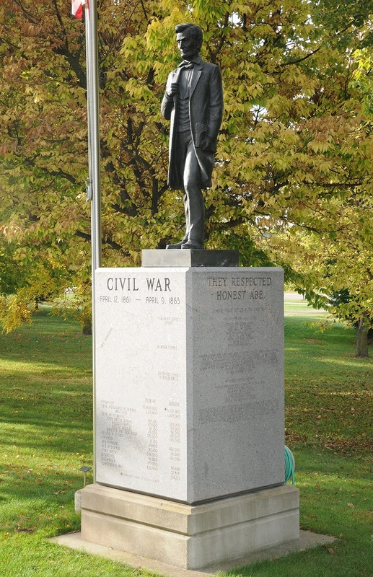Vintage Vagabond May trip on May 16 takes us to the Soldiers Walk at Memorial Park in Arcadia, WI. Stroll the one-third mile level walk to view monuments and statues commemorating all American wars/conflicts from the Revolutionary War to the 9-11 War on Terror. It is the largest Memorial Park in the United States, outside of Washington, D.C. Soldiers Walk- A Memorial Park dedicated to our Veterans: past, present and future- the perfect stop as we prepare for Memorial Day.

Our lunch stop will be at Newcomb Valley Inn near Arcadia Lunch includes a choice of a cheeseburger or pulled pork sandwich, fries, cookie and coffee.

 Then we are off to the Elmaro Vineyard and Winery near Trempealeau. Visit includes a tour of the vineyard/winery and a wine tasting experience. Note: Must be able to do stairs for winery tour.

## Your Napa, Close to Home...

Cost for May Trip: $60 includes transportation on Lamers Deluxe Motorcoach, meal including gratuity, and tour. Pick up times: Tomah- 8:30 a.m. and Sparta- 9:00 a.m. at Southeast corner of Wal-mart parking lots. Deadline for registering: April 11.

We have a new process for registering for trips this year. Please complete the form below. Then either mail, or bring in person to the ADRC office, your form and money. Cash or check must accompany your reservation. Keep checking the ADRC website for additional details for upcoming trips. Click on the Vintage Vagabond link on the left side of the page. <https://www.co.monroe.wi.us/departments/aging-and-disability-resource-center/senior-vintage-vagabond-trips>

>>>>>>>>>>>>>>>>>>>>>>>>>>>>>>>>>>>>>>>>>>>>>>>>>>>>>>>>>>>>>>RESERVE YOUR SPOT TODAY- **Deadline: April 11**

Vintage Vagabond Trip: **May 16 Soldiers Walk in Arcadia & Elmaro Vineyard & Winery**

Number attending: ___________ Pick up location: Tomah ____ or Sparta ____

Name(s) (Please print) 1._____________________________________2.______________________________

X if age 60+ ____ X if age 60+____

Address w/ city:__________________________________________________________

Phone number:_________________________Email____________________________

Meal Choice: Cheeseburger______ or Pulled Pork Sandwich_______

Payment: Total Enclosed $__________ Cash_____ or Check_____(made out to the ADRC of Monroe County)

**Mail or bring in person to: ADRC, 315 W. Oak St, Suite A Sparta, WI 54656**

**>>>>>>>>>>>>>>>>>>>>>>>>>>>>>>>>>>>>>>>>>>>>>>>>>>>>>>>>>>>>>>>**