# October 2022

*Senior Medicare Patrols (SMPs) empower and assist Medicare beneficiaries, their families, and caregivers to prevent, detect, and report heath care fraud, errors, and abuse through outreach, counseling, and education.*

Please feel free to share this publication with others who may benefit from its contents.

**TO CONTACT WI SMP**

**Call:** (888) 818-2611

1. **mail:** [smp-wi@gwaar.org](mailto:smp-wi@gwaar.org)

**Website:** [www.smpwi.org](http://www.smpwi.org/)

**Facebook:**

@WisconsinSeniorMedicarePatrol

# There Are No New Medicare Cards!

The scams related to Medicare cards persist! Beneficiaries from around the state continue to receive calls asking them about their Medicare card. The caller often identifies themself as being from Medicare, and that they are “just following up on the status of your Medicare card”.

The scam has a few variations, such as:

* + Asking the Medicare beneficiary if they have received the new Medicare card.
  + Questioning if they knew that their red, white, and blue Medicare card is going to expire. (There is no expiration date on the Medicare card.)
  + Inquiring if their doctor’s name is on their Medicare card. If not, the card needs to be updated to avoid interruption of services. (Health care provider information is NOT included on a Medicare card for any reason.)

When the beneficiary says that they have not received a new card, the caller is more than happy to help them get the “new or updated card”. The person on the phone then just asks them to “verify” their Medicare number.

If you receive this type of call, simply hang up, as the caller is trying to get your information to scam you and Medicare.

There is NOT a new Medicare card. Not a plastic card, a card with a chip, a different colored card, a laminated option, or a different card because of COVID-19. There are NO NEW Medicare cards, for any reason. Your paper red, white, and blue card is the only card issued by Medicare.

Over please.

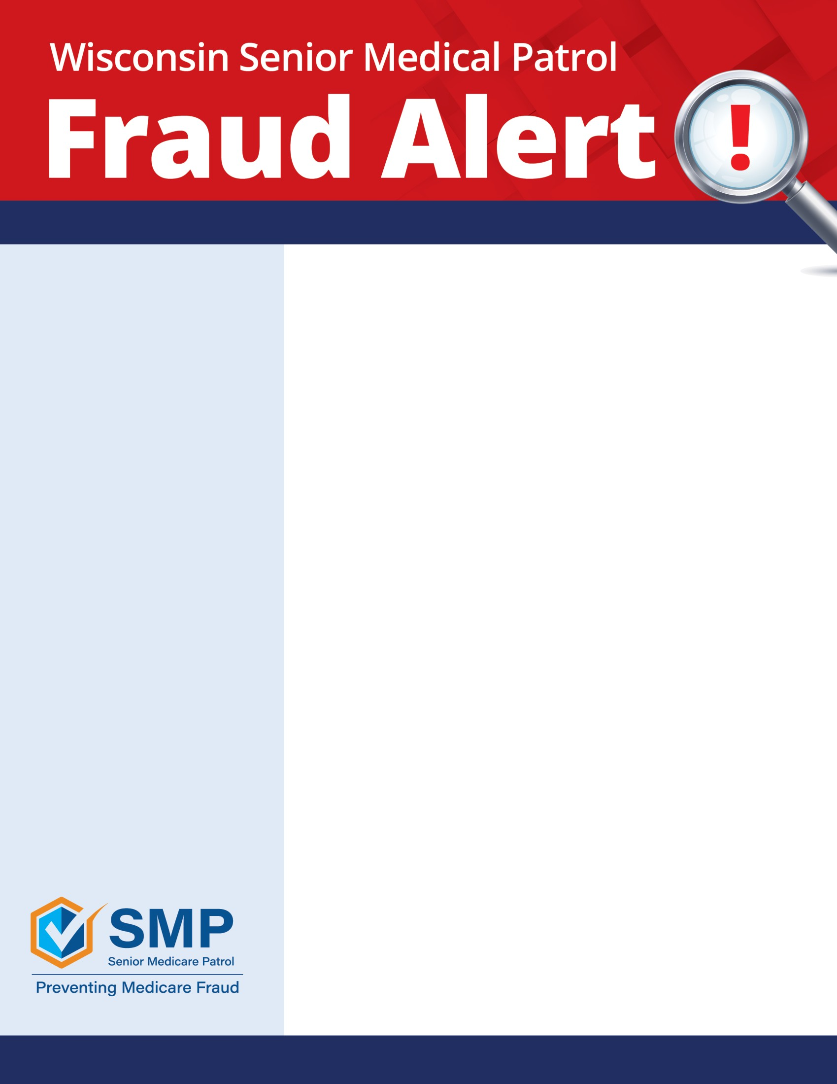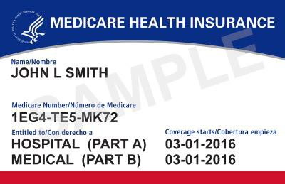

Funded by: This project was supported, in part by grant number 90MPPG0041-01-00, from the U.S. Administration for Community Living, Department of Health and Human Services, Washington, D.C. 20201. Grantees undertaking projects under government sponsorship are encouraged to express freely their findings and conclusions. Points of view or opinions do not, therefore, necessarily represent official Administration for Community Living policy.



**Protect Yourself with These Tips**

* Be aware that no one from Medicare, Social Security, or the IRS will call you
* No one from Medicare, Social Security, or the IRS will visit you at home or at a community event
* Be cautioned that scammers’ technology can make the phone number on your screen appear that the call is from Medicare, Social Security, or the IRS
* Medicare, Social Security, or the IRS will not threaten that your coverage or payments will be cut off if you do not comply
* If the caller is pressuring you to act now and giving you a sense of urgency, it is a scam

**Keep in Mind**

* Do not give out your Medicare number except to your doctor or other Medicare provider
* Treat your Medicare card like your credit card
* Do not share any personal information or bank information
* If it sounds too good to be true, it usually is
* Be cautious of offers for “free” medical services
* Watch out for identity theft

**Learn More on How to Protect Yourself**

* The Senior Medicare Patrol website: [www.smpwi.org](http://www.smpwi.org/)
* Contact your local Aging and Disability Resource Center, ADRC. To find the office in your area, visit: <https://www.dhs.wisconsin.gov/adrc>
* [Federal Trade Commission | Protecting America's Consumers (ftc.gov)](https://www.ftc.gov/)
* [National Do Not Call Registry](https://www.donotcall.gov/) [www.donotcall.gov](http://www.donotcall.gov/)

**Wisconsin SMP is available for outreach events, educational sessions for beneficiaries, caregivers and professionals, workshops and exhibits at events.**

**Please contact us at** [**www.smpwi.org**](http://www.smpwi.org/) **for more information**

@WisconsinSeniorMedicarePatrol