Friday September 23rd Vintage Vagabond

Join the ADRC of Monroe County as we take a step back in time to visit the Village Shops at Down a Country Road. We will arrive there at 1 pm so you can enjoy shopping at their unique, one of a kind stores, including an ice cream parlor! After about one hour we will leave from the shops to take a tour of Amish Country, stopping at two Amish farms. We will end the day at Badger Crossing pub and eatery at 4:30 for an early supper, offering you a choice of Fish or Chicken. Meal includes coffee, salad bar, dessert and gratuity.

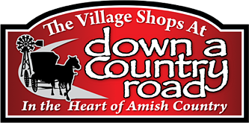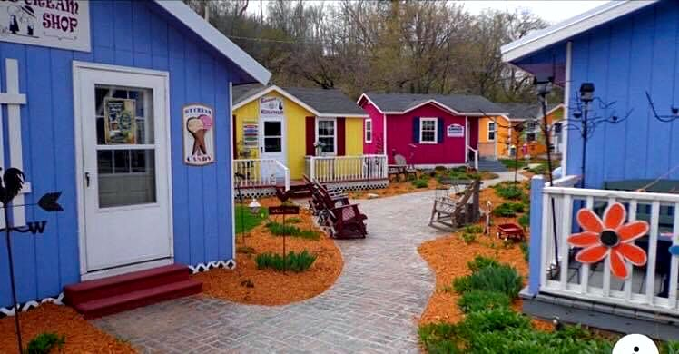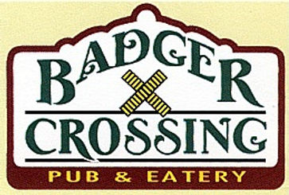

Cost of $70 includes the tour, dinner and transportation. Payment must be made by September 9th to reserve your spot. Call the ADRC at 608-269-8690 to make your reservation.