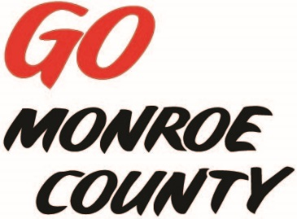 **MONROE COUNTY ECONOMIC DEVELOPMENT, COMMERCE**

**& TOURISM COMMITTEE**

14345 County Highway B, Room 3

Sparta, WI 54656

608-269-8006

**Regular Monthly Meeting**

**Local History Room (use back door)**

**Sparta, WI**

**9 a.m. Thursday, November 12th, 2015**

**Agenda**

1. Call to order/Roll Call
2. Approval of minutes of Sept. & Oct. meeting – (emailed with agenda)
3. Approval of Invoices/Budget Review
4. Tour of Jail - **9:30 a.m.**
5. Advertising Opportunities
6. EDCT Conference Sub-committee Report
7. ED Coordinator Report
8. 5 minute reports:
   1. Hidden Valleys (Bernie)
   2. ITBEC (Nodji)
   3. Chambers of Commerce (Tina, Tim)
   4. WATA
   5. 7 Rivers Alliance – Downtown Revitalization Seminar
   6. Fort McCoy (introduce new rep)
9. Unfinished business discussion/action
10. Next meeting date/location – Oct 10th 9 a.m. (location t.b.a.)
11. Adjourn

*Sharon Folcey, Chair* Date posted: November 2, 2015