Date: February 3, 2021

To: Monroe County News Agencies

From: Tina Osterberg, Monroe County Administrator

Re: Monroe County District Attorney awarded Prosecutor of the Year

District Attorney Croninger Named 2020 Wisconsin Prosecutor of the Year

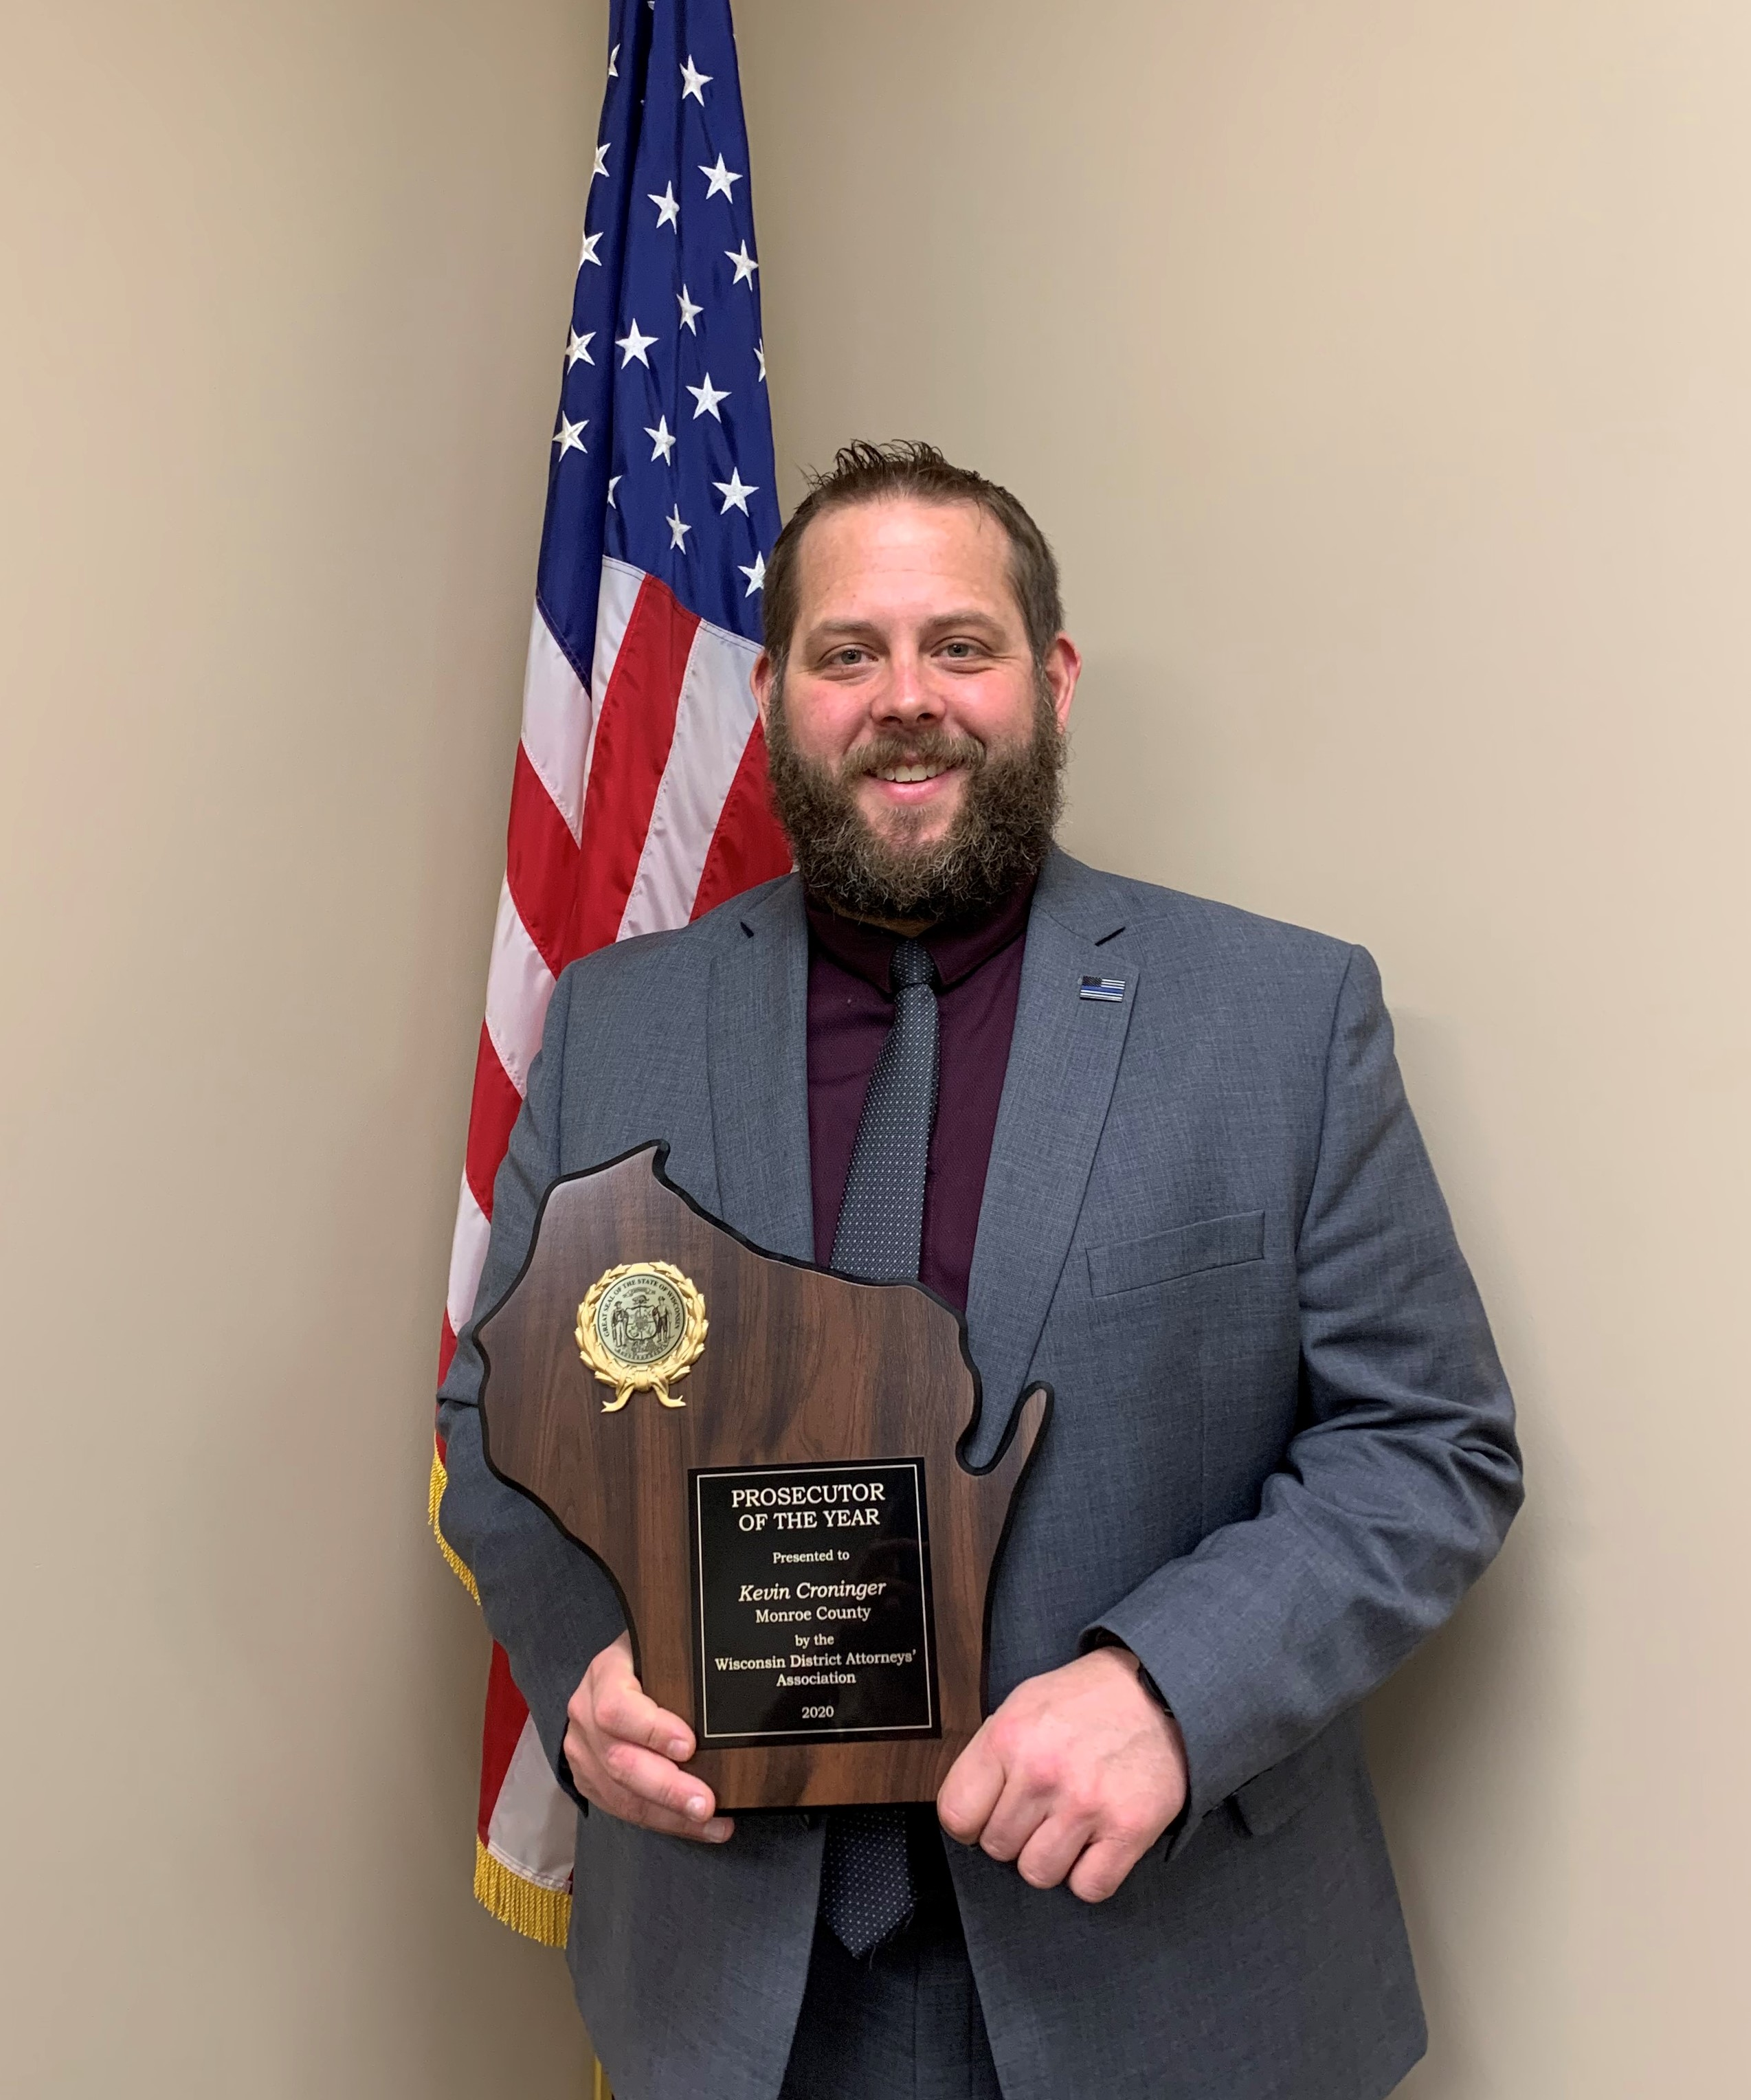
On January 08, 2021, Monroe County District Attorney, Kevin Croninger, was named the 2020 Wisconsin Prosecutor of the Year. The award is given annually by the Wisconsin District Attorneys Association, which is a group representing over 500 District Attorneys, Deputy District Attorneys, and Assistant District Attorneys across Wisconsin. While the award is a statewide award, Monroe County has been fortunate to have two recipients of the award, Croninger in 2020 and late Monroe County District Attorney Dan Cary in 2012.

Croninger was nominated for the award by Sparta Police Chief Emilee Nottestad, Sparta Police Sergeant Kyle Erickson, and Monroe County Assistant District Attorney Sarah Skiles.

Skiles wrote in her nomination, “Kevin carries a significant caseload of the most serious and sensitive cases while attending to his other duties as District Attorney. Skiles continued, “Kevin is not one to back away from a tough fight, in fact he may enjoy it, and he is a fierce litigator.” Skiles concluded, “Kevin is a dedicated crime-fighter who is devoted to protecting and bettering the community and seeing justice done. He is a tremendous asset to Monroe County and the State as District Attorney.”

Nottestad wrote in her nomination, “Kevin has always been willing to prosecute challenging cases and he goes above and beyond his ‘job’ every day…Kevin is truly dedicated to the citizens and communities he serves. I feel tremendously grateful to work with him, and honored to nominate him.”

Erickson wrote, “He (Croninger) is tremendously dedicated to serving the Monroe County communities and officers here are fortunate to have such a supportive prosecutor. It is an honor to have Kevin Croninger as District Attorney.”

Croninger stated, “I am deeply honored and humbled, not only by my selection as the Prosecutor of the year, but more so that I was nominated by Chief Nottestad, Sergeant Erickson and Assistant District Attorney Sarah Skiles. All of which are top notch professionals in their fields whom I have a tremendous amount of respect for. I view this award as a reflection of the collective work of law enforcement and my office. I am extremely proud of the work done by local law enforcement. I am also extremely proud of the staff in my office, whom I believe are some the best if not the best public servants in the State of Wisconsin. “

Croninger along with three of his staff were also recognized for their work in 2017. In 2017 Croninger was awarded the Outstanding Victim Advocacy by a Professional Award, from the Wisconsin Victim/Witness Professional Association. While staffers were awarded one Outstanding Victim Advocacy by a Victim Advocate and two Honorable Mention for Outstanding Victim Advocacy, from the Wisconsin Victim/Witness Professional Association.

Contacts:
Monroe County District Attorney’s Office
(608) 269-8780

