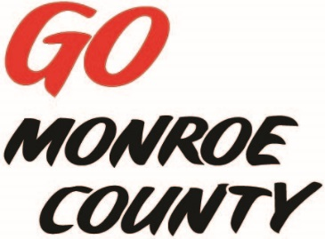 **MONROE COUNTY ECONOMIC DEVELOPMENT, COMMERCE**

**& TOURISM COMMITTEE**

14345 County Highway B, Room 3

Sparta, WI 54656

608-269-8006

**Regular Monthly Meeting**

**Ginny’s Cupboard**

**127 N Water Street, Sparta**

**9 a.m. Thursday, September 10th, 2015**

**Agenda**

1. Call to order/Roll Call
2. Approval of minutes of previous meeting – minutes available at meeting.
3. Committee Financial Review; 2016 Budget; Invoice review/approval
4. Monroe County Connect Community update
5. Downtown Revitalization Seminar
6. Website discussion/action
7. Economic Development Conference
8. ED Coordinator Report
9. 5 minute reports:
   1. Fort McCoy (Linda)
   2. Hidden Valleys (Bernie)
   3. Chambers of Commerce (Tina, Tim)
   4. WATA (Steve)
   5. 7 Rivers Alliance
   6. SW-ITBEC (Nodji)
10. Unfinished business discussion/action
11. Next meeting date/location
12. Adjourn

*Sharon Folcey, Chair* Date posted: September 8, 2015