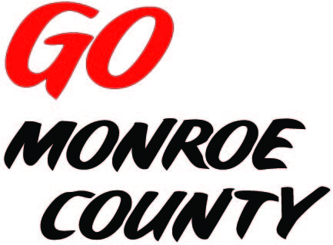 **MONROE COUNTY ECONOMIC DEVELOPMENT, COMMERCE**

**& TOURISM COMMITTEE**

14345 County Highway B, Room 3

Sparta, WI 54656

608-269-8006

**\*\*NOTE DATE CHANGE\*\***

**Regular Monthly Meeting**

**Gordy’s Supermarket – upstairs**

**Conference Room, 701 E. Clifton, Tomah**

**9 a.m. Thursday, August 20th, 2015**

**Agenda**

1. Call to order/Roll Call
2. Tour and presentation by Gordy’s
3. Approval of minutes of previous meeting – minutes available at meeting.
4. Committee Financial Review; 2016 Budget; Invoice review/approval
5. Monroe County Connect Community update
6. Website discussion/action
7. Reducing County Board discussion
8. Downtown Revitalization Seminar
9. ED Coordinator Report
10. 5 minute reports:
    1. Fort McCoy (Linda)
    2. Hidden Valleys (Bernie)
    3. Chambers of Commerce (Tina, Tim)
    4. WATA (Steve)
    5. 7 Rivers Alliance
    6. SW-ITBEC (Nodji)
11. Unfinished business discussion/action
12. Next meeting date/location
13. Adjourn

*Sharon Folcey, Chair* Date posted: August 12, 2015