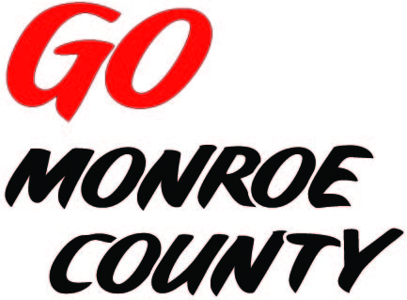 **MONROE COUNTY ECONOMIC DEVELOPMENT, COMMERCE**

**& TOURISM COMMITTEE**

14345 County Highway B, Room 3

Sparta, WI 54656

608-269-8006

**Regular Monthly Meeting**

**Cashton Elementary School**

**436 Front Street**

**9 a.m. Thursday, July 9th, 2015**

**Agenda**

1. Call to order/Roll Call
2. Introductions and tour
3. Approval of minutes of previous meeting – minutes available at meeting.
4. Committee Financial Review; 2016 Budget; Invoice review/approval
5. Monroe County Connect Community update
6. Website discussion/action
7. Upcoming meeting locations
8. ED Coordinator Report
9. 5 minute reports:
   1. Fort McCoy (Linda)
   2. Hidden Valleys (Bernie)
   3. Chambers of Commerce (Tina, Tim)
   4. WATA (Steve)
   5. 7 Rivers Alliance
   6. SW-ITBEC (Nodji) – no July meeting
10. Unfinished business discussion/action
11. Next meeting date/location
12. Adjourn

*Sharon Folcey, Chair* Date posted: June 29th, 2015