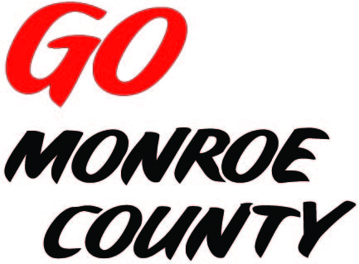 **MONROE COUNTY ECONOMIC DEVELOPMENT, COMMERCE**

**& TOURISM COMMITTEE**

14345 County Highway B, Room 3

Sparta, WI 54656

608-269-8006

**Regular Monthly Meeting**

**Pizones - Tomah**

**202 Superior Ave**

**9 a.m. Thursday, June 11th, 2015**

**Agenda**

1. Call to order/Roll Call
2. Approval of minutes of previous meeting – minutes available at meeting.
3. Committee Financial Review; Invoice review/approval
4. ED Coordinator Report
5. Ad for ED Magazine
6. Update on Connect Community (Monroe County)
7. Final Conference Report
8. *Gomonroecounty.com* & *Bikes&Berries.com* Websites
9. Potential Marketing ideas
10. 5 minute reports:
    1. Hidden Valleys (Bernie)
    2. Chambers of Commerce (Tina, Tim)
    3. Fort McCoy (Linda)
    4. Bikes & Berries/Local History Room (Jarrod)
    5. SW-ITBEC (Nodji)
    6. WATA (Steve)
    7. 7 Rivers Alliance
11. Unfinished business discussion/action
12. Next meeting date/location
13. Adjourn

*Sharon Folcey, Chair* Date posted: June 3rd, 2015