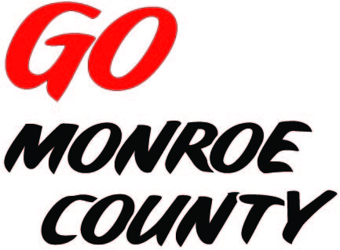 **MONROE COUNTY ECONOMIC DEVELOPMENT, COMMERCE**

**& TOURISM COMMITTEE**

14345 County Highway B, Room 3

Sparta, WI 54656

608-269-8006

**Regular Monthly Meeting**

**Theisen’s of Sparta**

**3000 S. Black River St.**

**9 a.m. Thursday, May 14th, 2015**

**Agenda**

1. Call to order/Roll Call
2. Approval of minutes of previous meeting – minutes available at meeting.
3. Committee Financial Review; Invoice review/approval
4. ED Coordinator Report
5. Gigabyte Park announcement/press conference
6. Connect Communities Pilot Program application update
7. *Gomonroecounty.com* & *Bikes&Berries.com* Websites
8. Potential Marketing ideas
9. 5 minute reports:
   1. Hidden Valleys (Bernie)
   2. Chambers of Commerce (Tina, Tim)
   3. Fort McCoy (Linda)
   4. Bikes & Berries/Local History Room (Jarrod)
   5. SW-ITBEC (Nodji)
   6. WATA (Steve)
   7. 7 Rivers Alliance
10. Unfinished business discussion/action
11. Next meeting date/location
12. Adjourn – Tour of Theisen’s

*Sharon Folcey, Chair* Date posted: April 29th 2015