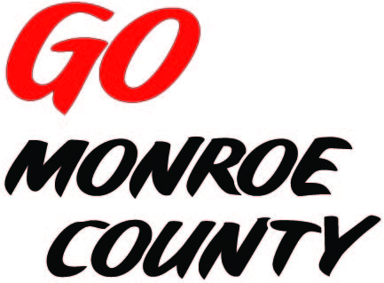 **MONROE COUNTY ECONOMIC DEVELOPMENT, COMMERCE**

**& TOURISM COMMITTEE**

14345 County Highway B, Room 3

Sparta, WI 54656

608-269-8006

**Regular Monthly Meeting**

**F&M Bank - Tomah**

**1001 Superior Ave**

**9 a.m. Thursday, April 9th, 2015**

**Agenda**

1. Call to order/Roll Call
2. Approval of minutes of previous meeting
3. Committee Financial Review; Invoice review/approval
4. EDCT Conference Wrap Up (Financials, Critique)
5. Monroe Co.  Industrial Parks
6. Connect Communities Pilot Program
7. Video progress
8. *Go Monroe County* Distribution
9. 5 minute reports:
   1. Hidden Valleys (Bernie)
   2. Chambers of Commerce (Tina, Tim)
   3. Fort McCoy (Linda)
   4. Bikes & Berries/Local History Room (Jarrod)
   5. SW-ITBEC (Nodji)
   6. WATA (Steve)
   7. 7 Rivers Alliance (Business Survey)
10. Unfinished business discussion/action
11. Next meeting date/location
12. Adjourn

*Sharon Folcey, Chair* Date posted: April 6th 2015