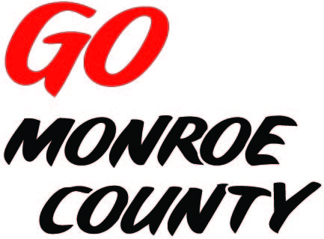 **MONROE COUNTY ECONOMIC DEVELOPMENT, COMMERCE**

**& TOURISM COMMITTEE**

14345 County Highway B, Room 3

Sparta, WI 54656

608-269-8006

**Regular Monthly Meeting**

**Sparta Barney Center**

**1000 E Montgomery**

**March 19, 2015**

**Agenda**

1. Call to order/Roll call
2. Approval of minutes of previous meeting (enclosed)
3. Committee Financial Review; Invoice review/approval
4. Economic Development Coordinator Report - Discussion/Action
5. **EDCT Conference** Feb. 26, 2015 report/critique
6. **Go Monroe County**
7. Video update/changes
8. 5-minute reports – Discussion/Action
   1. Hidden Valleys (Bernie)
   2. Chambers of Commerce (Tina, Tim)
   3. Fort McCoy (Linda)
   4. SW-ITBEC (Nodji)
   5. WATA (Steve)
   6. Bikes and Berries/Local History Room (Jarrod)
   7. 7 Rivers Alliance
9. Other new business – Discussion/Action
10. Next meeting: April 9, 2015 Location TBA
11. Adjourn

*Sharon Folcey, Chair* Date posted: