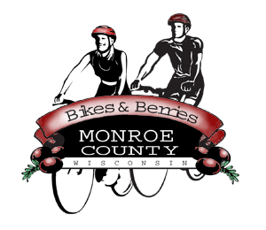 **MONROE COUNTY ECONOMIC DEVELOPMENT, COMMERCE**

**& TOURISM COMMITTEE**

14345 County Highway B, Room 3

Sparta, WI 54656

608-269-8006

**Regular Monthly Meeting**

**Activity Room, Rolling Hills**

**(first hallway past reception area; then room on right)**

**9:00am Thursday, Jan. 8, 2015**

**Agenda**

1. Call to order/Roll call
2. Approval of minutes of previous meeting (12/11/14 enclosed)
3. Committee Financial Review; Invoice review/approval
4. Economic Development Coordinator Report - Discussion/Action
5. Video update; invoice
6. EDCT Conference Feb. 26, 2015
7. Go Monroe County EDCT Publication
   1. Village/Towns narrative/maps
   2. Time Line; Ad Sales
8. 5-minute reports – Discussion/Action
   1. Hidden Valleys (Bernie)
   2. Chambers of Commerce (Tina, Tim)
   3. Fort McCoy (Linda)
   4. SW-ITBEC (Nodji)
   5. WATA (Steve) Conference March 30/31 in Wisconsin Dells
   6. Bikes and Berries/Local History Room (Jarrod)
   7. 7 Rivers Alliance
9. Other new business – Discussion/Action
10. Next meeting: 9:00am, Feb. 12 in Tomah (location TBA)
11. Adjourn

*Sharon Folcey, Chair* Date posted: December 29, 2014