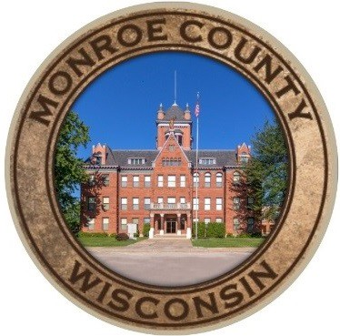
MONROE COUNTY BOARD OF SUPERVISORS
202 SOUTH K STREET, RM 1, SPARTA, WISCONSIN 54656
PHONE: 608-269-8705 FAX: 608-269-8747 www.co.monroe.wi.us

Public, you have the option to access this meeting remotely by phone or audio

Meeting link: https://monroecountywi.webex.com/
Meeting number: 146 879 8007
Password: mJkQzBaR248
Host key: 214720

Join by video system
Dial 1468798007@monroecountywi.webex.com
You can also dial 173.243.2.68 and enter your meeting number.

Join by phone IT Point of Contact
+1-408-418-9388 United States Toll Rick Folkedahl
Access code: 146 879 8007 608-633-2700

608-633-2700

MONROE COUNTY BOARD AGENDA – SPECIAL MEETING
Wednesday, June 10, 2020
5:00 p.m.
American Legion Post #100
1116 Angelo Road Sparta, WI 54656
*(Please use the South Parking Lot Entrance)

COUNTY BOARD / DEPARTMENT HEAD TRAINING SESSION

Call to Order/Roll Call

Pledge of Allegiance

Introduction of Monroe County Department Heads

Introduction of Monroe County Board Members

WCA Presentation, Sarah Diedrick-Kasdorf and Andy Phillips
- Roles of the Board
- Roles of the Department Heads
- Role of the Administrator
- Roberts Rules of Order
- Motion Procedures
- Open Meetings Law
- What Constitutes a Quorum
- Walking Quorum – All Types of Media
- Conflicts of Interest

(over)

Andrew Kaftan, Corporation Counsel
- Monroe County Board Rules
- Ethics
- Resolution Drafting
- General Fund, Contingency Fund and Bonding Approvals

Diane Erickson, Finance Director
- Line Item Transfers
- Budget Adjustments
- Repurpose of Funds

Tina Osterberg, Monroe County Administrator
- Department Head Expectations

Shelley Bohl, Monroe County Clerk
- Monroe County Website, Agenda’s & Minutes
- Monroe County Directory
- Monroe County Proceedings
- County Board Correspondence
- County Board Per-Diem Fillable Worksheets

Adjournment

This Special Board meeting has been called by the Chair and Vice Chair of the Board.
Your attendance is required. If you are unable to attend, please contact the Chair at
608-269-5228 or district.04@co.monroe.wi.us

Due to the COVID-19 Pandemic, the Monroe County Board will be following CDC recommendations.
We will keep distancing of at least 6 feet, masks and hand sanitizers will be on location. We ask that if you are running a temperature or are not feeling well, please do not place others at risk.

